CMSC203 Assignment 1 Implementation (Documentation)

Class: CMSC203 CRN 21305
Program: Assignment #2
Instructor: Professor Grinberg
Summary of Description: Take in a patient, their procedure and their contact information, charge
them for it, and calculate the number of expensive procedures and the highest, average, and total
charge for the procedures.
Due Date: 09/21/2026
Integrity Pledge: I pledge that I have completed the programming assignment independently.
I have not copied the code from a student or any source.
Student Name: Jacen Cheskin

Part1: UML Class Diagram:
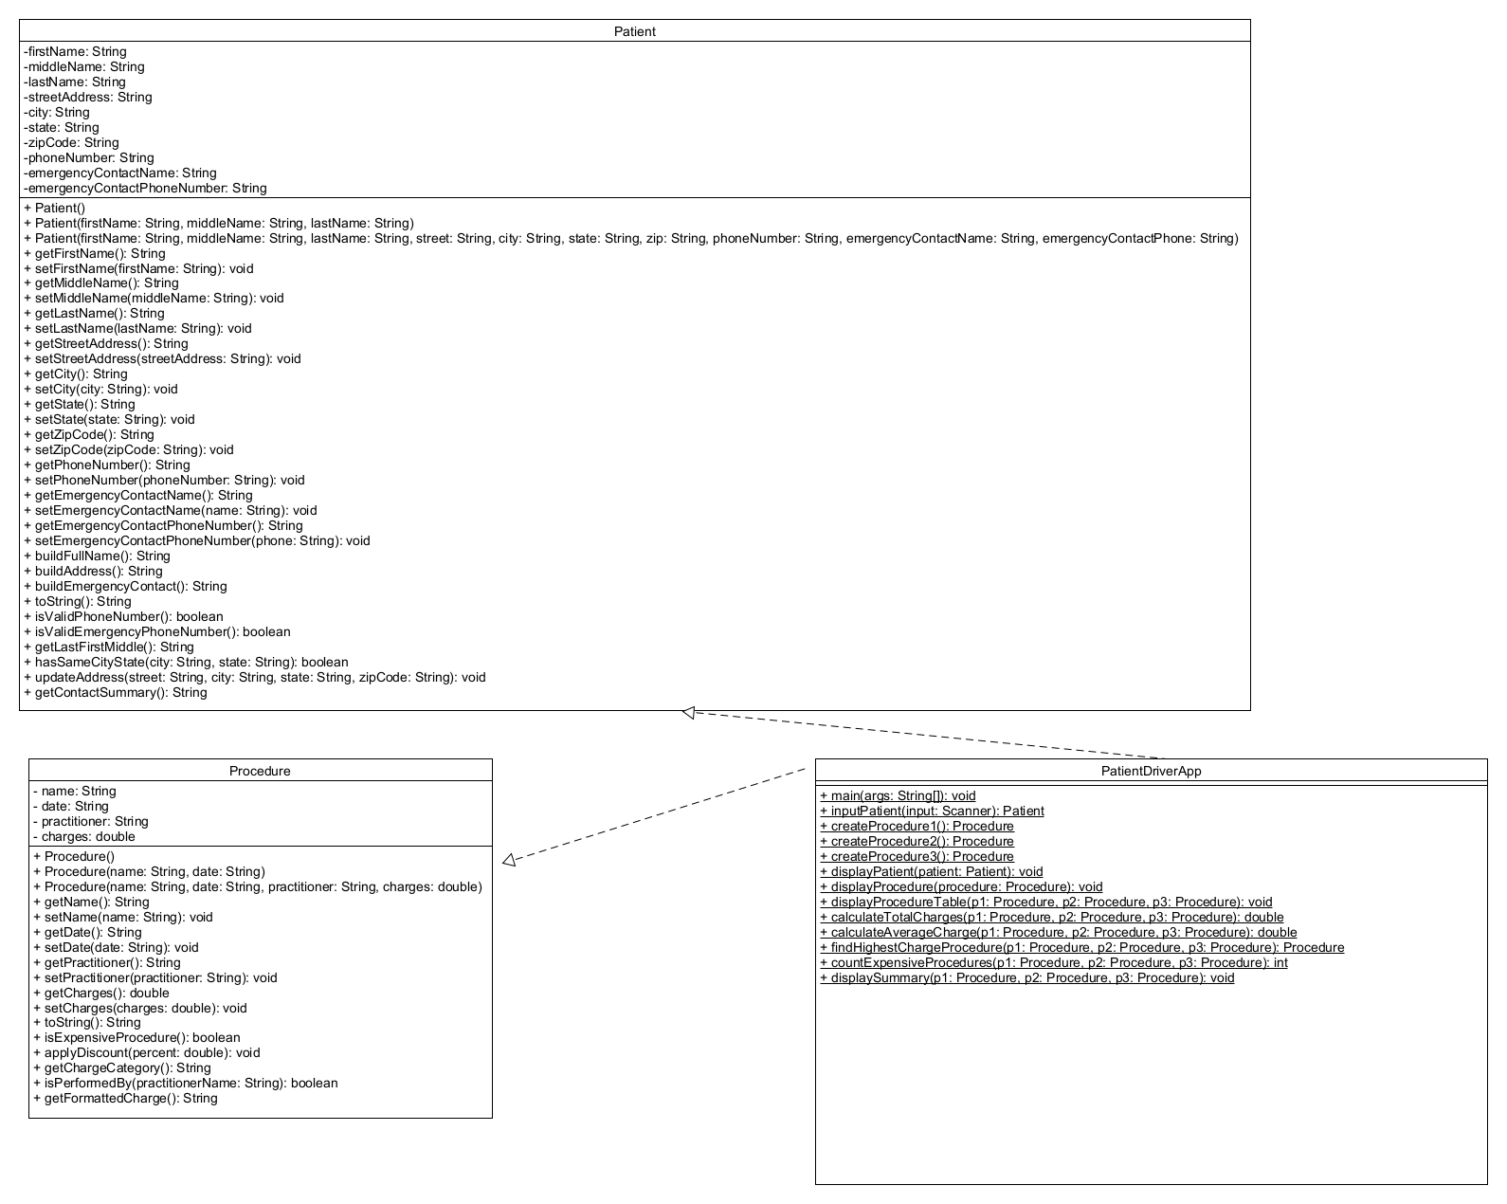

Part2: Comprehensive Test Plan
A good test plan should be comprehensive. This means you should have a few test cases that test when the input is in and out of range, division by 0, incorrect Data type, etc. (Provide valid and invalid input)
Cases | Input | Expected Output | Actual Output | Did the test pass?
Case 1 | Jenny Elaine Santori, 123 Main Street MyTown CA 01234, 301-123-4567, Bill Santori, 777-555-1212 | both phones valid, table shows Low/Medium/High; Total $2,201.18, Average $733.73, Highest = Blood Test, Expensive = 1 | both phones valid, table shows Low/Medium/High; Total $2,201.18, Average $733.73, Highest = Blood Test, Expensive = 1 | yes
Case 2 | Mark Allen Cooper, 3011234567 (no dashes), Lisa Cooper, 240-55-9999 (bad format) | Phone Valid: false, Emergency Phone Valid: false | Phone Valid: false, Emergency Phone Valid: false | yes
Case 3 | Set a procedure charge to 1000.00 | Additional expensive procedure (2 total) but still marked as medium cost. | Additional expensive procedure (2 total) but still marked as medium cost. | yes
Case 4 | Apply 20 % discount to procedure 1 | 800 (20% discount of 1000) | 800 | yes

Part3: Screenshots related to the Test Plan:
Case 1
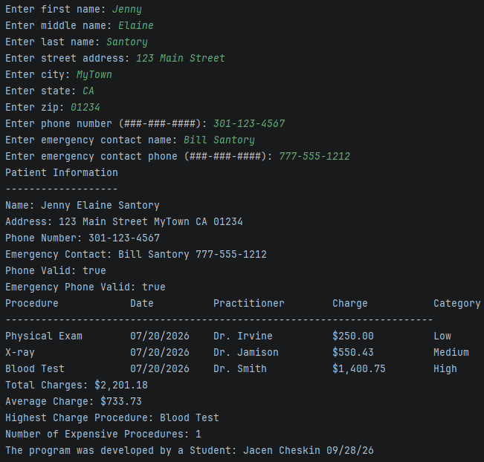
Case 2
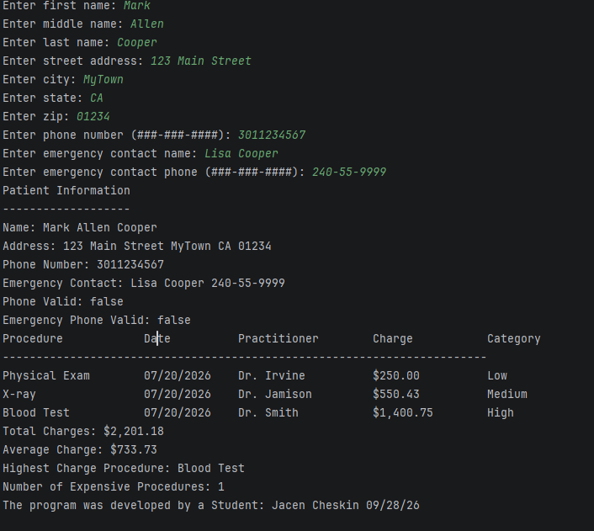
Case 3
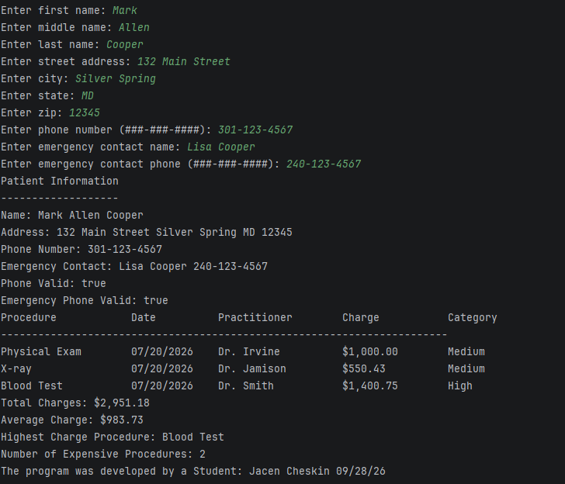
Case 4

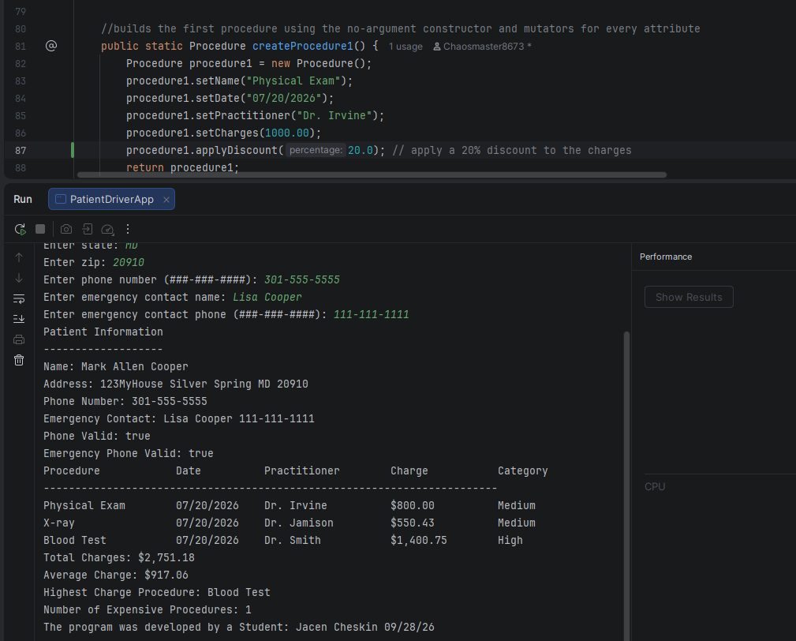

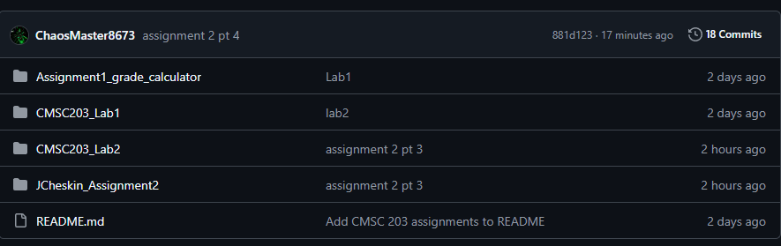

Lessons Learned <Provide answers to the questions listed above>:

Write about your Learning Experience, highlighting your lessons learned and learning experience from working on this project.
Describe your overall learning experience working on this project.
I learned how to make classes and how to give them lots of methods. I also learned that every variable in a class that is not final should have setter and getter methods.

What did you struggle with?
I struggled with making sure I had all the setters and getters. On a large class like the patient class I accidentally was missing a setter and did not realize until I was almost done.
What new concepts or techniques did you learn?
I learned about object-oriented programming and classes. I also learned about encapsulation and making variables private.
What aspects of this assignment were the most challenging, and how did you address them?
The most challenging part was making sure I had all my methods. I addressed this by recounting and trying to divide them into categories of methods.
What would you do differently on your next project?
I would more clearly divide up the methods so I can have an easier time seeing which ones I’m missing. I would also commit more to GitHub throughout the process.
Which parts of the assignment were you most successful with, and which (if any) were you not
successful with?
I was most successful with calling my methods. I was also successful with ensuring all my methods worked.

Check List: <Provide answers to the column Y/N or N/A >:

# |  | Y/N | Comments
 | Assignment files:
 | - FirstInitialLastName_ Assignment2_JavaFiles.zip | Y
 | - FirstInitialLastName_Assignment2_Complete.zip | Y
 | - Source Java files  - Documentation_File.docx | Y
 | Program compiles | Y
 | The program runs with the desired outputs related to a Test Plan | Y
 | Documentation file: | Y
 | - Comprehensive Test Plan | Y
 | - Screenshots related to the Test Plan | Y
 | - Screenshots of your GitHub account with submitted Assignment# (if required) | Y
 | - UML Class Diagram | Y
 | - Lessons Learned | Y
 | - Checklist is completed and included in the Documentation | Y

